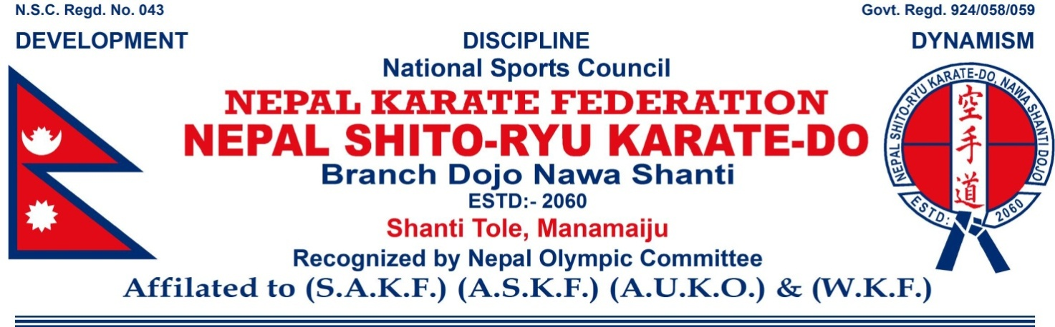
Official Invitation
Dear President, Shihan, Sensei&friend.
It is our great Pleasure to invite you officially to the 18thIndoNepal Karate& Kickboxing Championship 2023. Which will takeplace in the Kathmandu, Nepal from 23th December 2023.

It’s the Organization’s 18thevent that means it’s not exclusively it has the aim together all competitors from India and Nepal. So clubs can participate with unlimited numbers or athletes, coming from India.

This initiative relay wants to be with everybody, for everybody and everybody's, characterized by the highest values of sport.

We wait for you all in the Kathmandu for the event of the year 2019.

We hope you would gladly receive our invitation and participate in the Championship. Since competitors and organizations are supposed to exchange their e-mail address and contact details. We would appreciate yours assistance in forwarding this invitation to any interested competitors.

Thank you for the co-operation for making the 18thIndoNepal Karate & Kickboxing championship 2023 grand success.

Yours Sincerely

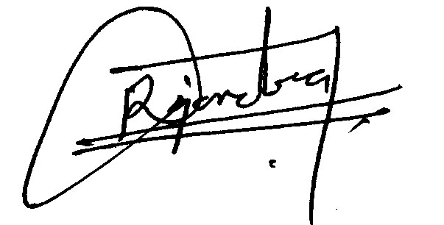
__________________
Rajendra Kumar Ojha
Chairman
Organizing Committee
For further details and information contact us:
+9779851034612, +9779841232080
+9779851034612,Viber,WhatsApp& Imo
E-mail:samakhushidojo@gmail.com
ojha_guru@yahoo.com
Website:www.karatenepal.com.np

18th IndoNepal Karate & Kickboxing Championship-2023
Organized by:
Nepal Shito-Ryu Karate - Do
Branch Dojo Nawa Shanti
1. Events Male Individual Kumite& Kickboxing
20 kg | 25 kg | 30 kg | 35 kg | 40 kg | 45 kg | 50 kg

55 kg | 60 kg | -65 kg | +65 kg | Junior kata under 12 years | Senior above 12 years

50kg (K.B) | 55kg (K.B) | -60 kg (K.B) | +60 kg (K.B)

Female Individual Kumite & Kickboxing

20 kg | 25 kg | 30 kg | 35 kg | 40 kg | 45 kg | 50 kg

-55 kg | +55 kg | Junior kata under 12 years | Senior above 12 years

45kg5 45kg (K.B) | 50kg (K.B) | -55 kg (K.B) | +55 kg (K.B)
2. Competition Rules & Regulation
- All payment must be received by organized committee before the championship starts.
- Each country or team may enter any number of participants in each category.
- The competition area will be a square with sides of 8 meters.
- If there are insufficient of referee and judges 4 corner judges system will be adopted.
- Two winners can participate for IndoNepal championship from each country.
- The technical committee will be final decision taken.
- Organization committee will not responsible for any injuries during the championship, first aid facility will be provided.
- The decision of Referee co-ordinate will be final, Objections against the same is misbehavior. With organizing committee it can result to disqualification of whole term or individual.
- In all categories 8 participants are must in case of incomplete participants that weight categories can be mixed with next weight categories and same rule applicable in kata events.
- Entry fees will not be refundable at any circumstances.
- Two password size photo of each participants and coach are must for Id card for entrance in championship.
- The championship tie sheet will be draw with software.
- Organizer has the right to allow or cancel any events & weight categories.
- Each club is supposed to bring the national flag and national anthem.
3. Arrival 21th December 2023
4. Weight check 22th December 2023
5. Championship23th December 2023.
6. Departure 24th December 2023.
7.VenueKathmandu, Nepal.
8. EventKumite, kata & Kickboxing Championship.
9. Award Ceremonies
- The Awards ceremony shall start after the competition of event.
- First Prize: Gold Medals and Diplomas to the first winner in each category
- Second Prize: Silver Medals and Diplomas placed in the second in each category.
- Third Prize: Two Bronze Medals and Diplomas to the Losing semifinalists in each category.
- Participation certificate will be provide all players.
- All Coaches we are provide Beautiful Momentous.
10. Trophies
- Team first trophy and Diplomas.
- Team second Trophy and Diplomas.
- Team third Trophy and Diplomas.
- Best Discipline Trophy and Diplomas.
- Boys' Best player Trophy and Diplomas.
- Girls' Best player Trophy and Diplomas
11.Closing Date
The Closing date for all entries will be on 10th December 2023.
The Organizing committee wish to have your reply on participation.
12. Duration of Bouts
The official duration of kumite matches will be 2 minutes for junior & woman, and seniors will be 3 minutes.
13.Only Entry fees
Participation Fees 1000.00 Indian rupees per contestant.
Extra event fees 500.00 Indian rupees.
We are provide 1days lunch in venue.
14. Hotel Expenses for Package per person
- Player Accommodation, Breakfast, Lunch, Dinner & Entry fee (4000ic).(for 3days)
- Guardian’s Accommodation, Breakfast, Lunch & Dinner(3500ic).(for 3days)
Accommodation provide 21st to 23rd December 2023.
(HOTEL Booking 50% Payment is must in advance i.e. before 10th December2023)
15.Bank Account
Rajendra Kumar Ojha , Account No 20115241406385S swift code is NSBINPKA Nepal SBI Bank Limited , Gongabu, Kathmandu, Nepal.
16.Safety Equipment
Mitts, foot protection and mouth guards are compulsory.
Mitts, mouth guard, foot protection, beltetc. shall be provided by the athletes themselves.
17. InsuranceAll participant and members of delegation must effect their own medical insurance and personal trip insurance. The organizing committee is not liable for this purpose.
18.Your Last Destination
B.G. Mall, New Bus Park, Gongabu, Kathmandu ,Nepal

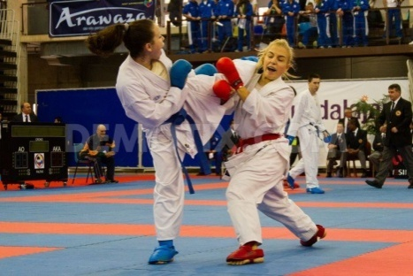
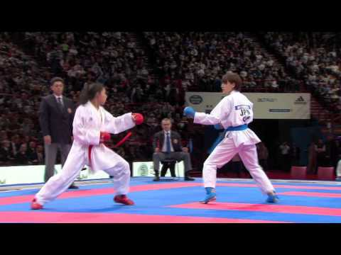
Heartily Welcome
Kathmandu
18th IndoNepal Karate
& Kickboxing
Championship-2023

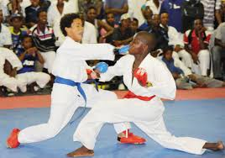

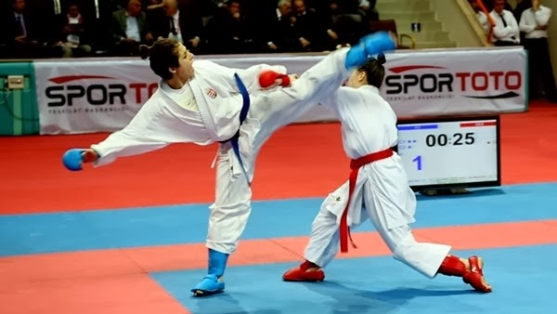
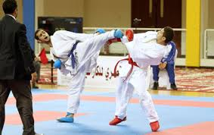

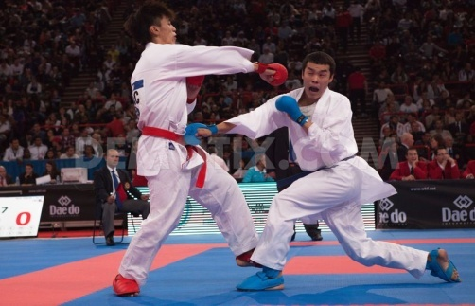

You can approach from any place to Kathmandu

Tourist places

- Royal Place 6 km
- Thamel 5 km
- Swaymbhu Temple 6 km
- Darbarsqare 7 km
- Boudhanath Temple 8 km
- Pasupatinath Temple 8 km
- Chandari Giri Hills 17 km
- Bhaktapur Darbarsqare 25 km
- Asia tallest Shiva Temple 30 km
- Patan Darbarsqere 12 km
- Pokhara 200 km
- Lumbini birth place of Lord Buddha 313km

18th IndoNepal Karate & Kickboxing Championship-2023
Organized by:
Nepal Shito-Ryu Karate - Do
Branch Dojo Nawa Shanti

PP Size
Photo
Kathmandu, Nepal
23th December 2023

PLAYER FORM

Name: …………………………………………………………………..…..
Date of Birth: ……………………………………………………………….
Age…………………………………………………………………..…….
Sex: …………………………………………………………………………
Weight: ……………………………………………………………………..
Event: ………………..………………………………………………….….
Instructor Name: ………………………………………………………..…..
Country: …………………………………………………………………….
I myself would be responsible for any accident or injuries during the championship.

………………………
Applicant Signature
18th IndoNepal Karate & Kickboxing Championship-2023
Organized by:
Nepal Shito-Ryu Karate – Do
Branch Dojo Nawa Shanti

No. | Name of Contestants | Date of Birth | Age | Sex | Weight | Event
1.
2.
3.
4.
5.
6.
7.
8.
9.
10.
11.
12.
13.
14.
15.
16.
17.
18.
19.
20.
 |  |  |  | Total
Competitors shall takes part in the above championships at their expense and risk.
The official and participants shall not be responsible for any accidence or injuries.
 | Name of Instructor & Manager |  |  |  | Signature
 | Name of The Country |  |  |  | Date
 | Address |  |  |  | E:mail

